

American International University-Bangladesh (AIUB)  
Department of Computer Science  
Faculty of Science & Technology (FST)  
Fall 22 23

Section: A/ B/ C  
Software Quality Assurance and Testing

Online Metrorail Ticket Booking System

A Report submitted

By

|  |  |  |
| --- | --- | --- |
| SN | Student Name | Student ID |
| 1 | Rashid, Ashfat Al | 19-40195-1 |
| 2 | Rahman, Md Shohan Ur | 18-38936-3 |
| 3 | Faruk, Tajkia | 19-40009-1 |
| 4 | Ahmed, Tahsin | 18-38936-3 |

Under the supervision of

ABHIJIT BHOWMIK

ASSOCIATE PROFESSOR

**Checked By Industry Personnel**

Name:

Designation:

Company:

Sign:

Date:

Software Test Plan

For

Online Metrorail Ticket Booking System

Version 1.0 approved

Prepared by Ashfat Al Rashid

American International University-Bangladesh(AIUB)

<date created>

**Checked By Industry Personnel**

Name:

Designation:

Company:

Sign:

Date:

Table of Contents

Revision History 3

1. TEST PLAN IDENTIFIER: RS-MTP01.3 4

2. REFERENCES 4

3. INTRODUCTION 4

Background to the Problem 4

Solution to the Problem 4

4. REQUEIREMNT SPECIFICATION 4

4.1 System Features 4

4.2 System Quality Attributes 5

4.3 System Interface 5

4.4 Project Requirements 5

5. FEATURES NOT TO BE TESTED 5

6. TESTING APPROACH 5

6.1 Testing Levels 5

6.2 Test Tools 6

6.3 Meetings 6

7. TEST CASES/TEST ITEMS 7

8. ITEM PASS/FAIL CRITERIA 7

9. TEST DELIVERABLES 8

10. STAFFING AND TRAINING NEEDS 8

11. RESPONSIBILITIES 8

12. TESTING SCHEDULE 9

13. PLANNING RISKS AND CONTINGENCIES 9

14. APROVALS 9

# Revision History

|  |  |  |  |
| --- | --- | --- | --- |
| Revision | Date | Updated by | Update Comments |
| 0.1 | 28.11.2022 | Ashfat Al Rashid | First Draft |
| 0.2 | 03.12.2022 | Md Shohan Ur Rahman | Second Draft |
| 0.3 | 07.12.2022 | Tajkia Faruk | Third Draft |
| 0.4 | 10.12.2022 | Tahsin Ahmed | Fourth Draft |

# TEST PLAN IDENTIFIER:RS-MTP01.3

# REFERENCES

* Software Requirement Specification (SRS) for Online Metrorail Ticket Booking System - https://github.com/AshfatAbegh/SRS-for-Online-Metrorail-Ticket-Booking-System-

# INTRODUCTION

## Background to the Problem

Online Metrorail Ticket Booking System is an online-based system where users can book an online train ticket from anywhere. In our country, people from all over the country come to the capital Dhaka in search of livelihood, so public transport is the sole way for many people to travel home to workstations. As we know Dhaka is known for traffic jams and overpopulation. To buy train tickets they have to stand and wait in a line and it kills their valuable time. People cannot use other vehicles easily as an option, because they have to face traffic jams. To solve this problem, we want to develop an online-based Metrorail ticket booking system. As the online train ticket is a new addition to the public transport sector people will start to rely on it on daily basis, so to remove the hassle of booking tickets from physical stations and long waiting ticket lines our project will help them in the process.

## Solution to the Problem

As the world is daily approaching the peak of technological achievement, our country is trying its best to cope-up with the rest of the world through the digitalization of its traditional systems and people are more into online-based solutions to their problems rather than solving them offline. The online train is a completely new addition to day-toy to day life public transport medium, as it’s a new transport system for the mass we wanted to make easily accessible for the people of our country. The online train ticket management system is a full fledge online-based system. By making an online based ticket booking system for public transport people will find it easy to travel through public transport and which will eventually help to eliminate traffic jams as part of the population will rely less on their personal vehicles. This online booking system will be both available on mobile applications and open browsers, people can access their account to their accounts on both platforms. All the user and system information will be stored in an internal database where people can get information about any online train-related queries with one click. As the whole solution is based on the convenience of the mass it has no business objectives and its sole reason is to make people’s life easier.

# REQUEIREMNT SPECIFICATION

## System Features

***User:***

1. The user can register into the system with his/her e-mail
2. The user can login into the system
3. The user can log out from the system
4. The user can view his or her own profile
5. The user can view the location of the train
6. The user can purchase ticket
7. The user can file a complaint if there is any
8. The user can see the number of station nearby him/her and available trains
9. The user can have both language option in Bangla and English
10. The user can choose to pay for the purchase ticket by MFS or by MasterCard

***Admin:***

1. Admin can see his own profile
2. The admin has both login and logout function
3. The admin can see the total number of purchase ticket
4. The admin can see the available trains and the schedule of the trains
5. The admin can see complaints of the users
6. The admin can see complaints that have already been solved by the stuff
7. The admin can change the time of train schedule
8. The admin can also insert or delete users

## System Quality Attributes

**Reliability:**

* In a technological environment, the data communication protocol must maintain the reliability and quality of data and voice transmission.
* The memory system must be non-volatile, for example, CDMA/GSM.

**Availability:**

* In the event of a communication problem, the system will be shut down.
* The system must be manually restarted by maintenance employees or the director of management after an untrustworthy shutdown.
* No inconsistency in the account should be introduced throughout the system's booking.
* The system will be shut down as a result of this.
* The system must comply with AIMS security requirements.
* The system must have two levels of security, one for login verification and the other for code verification, both of which are authenticated by the CMS software.
* During code transmission, the encryption standard must be triple DES.
* The password should be between six and ten characters long.
* Passenger names should not be included in passwords because they are easily compromised.
* Numbers, hyphens, and underscores can all be used in passwords.
* The user should be given only three attempts to log in, after which his/her booking should be canceled.

**Usability:**

* The web application is designed in such a way that every stages of people can use it easily.
* The functionality of every component in the system is very much convenient to use.
* Overall user interface is minimal so that every functionality of web elements can visualize easily.

**Integration:**

* As it’s an online metro rail ticket booking system the whole system is very large. Though the system is very large it’s not an issue for the passengers nor for the admin because of it’s integration attribute.
* The system has two different modules. One is for the user and another one is for admin. User modules have so many features as well as the admin has some different features which can’t be accessible from a user dashboard. So, the system integration part is a necessary requirement for building an entire application.
* In the phase of system integration data is updated across all components of the system simultaneously, keeping all departments on the same page.
* Data is no longer scattered across siloed storages. So, to perform analytics, you don’t need to manually download and export it to the centralized repository. Instead, with a holistic view of all information, you can extract useful business insights to make good decisions more rapidly.

## System Interface

***User Dashboard:***

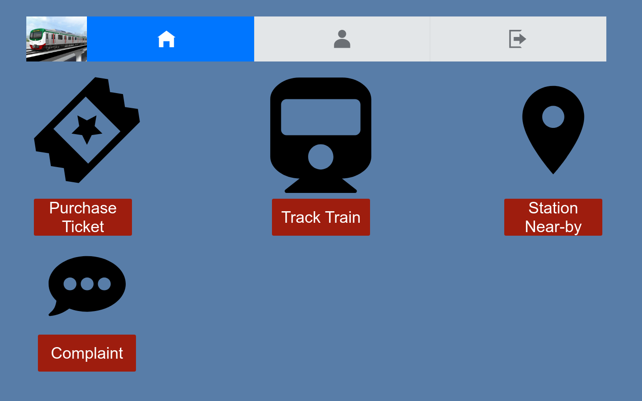

***Admin Dashboard:***

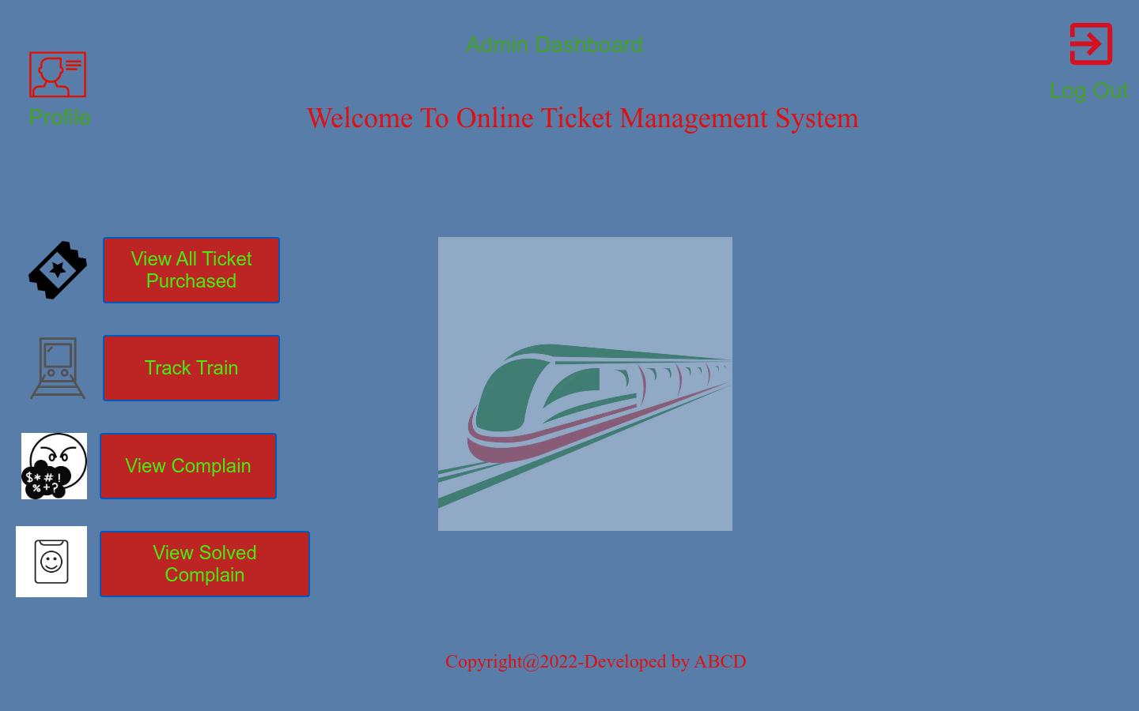

## Project Requirements

* Time: 7 Months (Estimated)
* Budget of 5 Lac (Estimated) BDT
* Need team of 05 members.
* Members should have proper technical knowledge.
* Dedicated IDE for development
* Dedicated QA team for testing
* A space for collaboration

**5**. FEATURES NOT TO BE TESTED

The features which are not to be tested are as follows:

* Types of users
* Maintenance of servers
* Maintenance of user records
* All Purchased tickets
* Solved Complain
* Finance and annual report of the overall ticket sell

# 6. TESTING APPROACH

## 6.1 Testing Levels

In this project, we will implement a test plan for the **Online Metrorail Ticket Booking System.** To continue testing software in relation to the project, we need to go through major stages of testing. Several test levels need to be addressed.

**1) Development:** A **white-box testing** technique that tests the internal structure of an application. White-box testing requires a tester to step through the code line by line to ensure that internal operations are performed according to specifications and that all internal modules are properly implemented. We can use white-box testing during the development of our Online Metrorail Ticket Booking System to ensure that our system is functioning properly. Currently, there are several different types of white-box testing and these types of strategies can be used in test planning.

**2) Unit Testing: Unit testing** is one of the basic steps performed in the early stages. Most testers prefer to see if a particular unit is working properly or not. Unit tests are one of the general steps performed for each activity because they help eliminate basic and simple bugs. Therefore, after completing each unit and module, we can create a test case and run a unit test to see if the module works as expected. For unit tests, there are also static and dynamic unit tests.

**The static analysis** step contains testing some of the static elements in our code. This step is performed to find one of the defects or errors that can occur in our application code. This step is important to rule out simple errors early in the testing process. **Dynamic analysis** is the next step in static analysis in a typical path test. Dynamic analysis helps us analyze and run the source code according to our requirements. The final stage of the step helps in analyzing the output without affecting the process.

**3) Smoke Testing: Smoke testing** is a software testing process that determines if a delivered software build is stable. A smoke test is a confirmation for the QA team to proceed with further software testing. It consists of a minimal set of tests that are run on every build to test software functionality. Smoke tests are also called "build verification tests" or "reliability tests".

Simply put, smoke testing means making sure that your critical functionality is working and that the build you're testing isn't failing. This is a small, fast regression test of key features. This is a quick test to show that the product is ready for testing. This helps determine if the build has bugs, and further testing would be a waste of time and resources.

6) **API Testing**: **API testing** is a type of software testing that tests application programming interfaces directly and as part of integration testing to determine whether they meet expectations for functionality, reliability, performance, and security. API testing is done at the message level since the API does not have a GUI.

5) **Regression Testing: Regression testing** is defined as a type of software testing to ensure that recent program or code changes do not adversely affect existing functionality. Regression testing is simply a full or partial selection of previously executed test cases that are re-executed to ensure that existing functionality works correctly. These tests are run to ensure that new code changes do not adversely affect existing functionality. This ensures that old code continues to work after the latest code changes have been made.

**6) System Integration Testing:** For our **Online Metrorail Ticket Booking System,** we will implement **System integration testing** or **SIT**. SIT is mainly done to check how individual modules interact with each other when integrated into a system as a whole. It is conducted after unit testing and will be done each time when a new module is added to the system. SIT test cases focus on the interface between the system components.

7) **User Acceptance Testing:** And last but not least we will go through **Acceptance testing**. With the help of our development team, it will be done by the final users. They will check whether our system meets all the user requirements or not.

**6.2.** Test Tools

For a proper bug free Online Metrorail Ticket Booking System we need to test the system and look for the bugs in the system. We need to test the system based on functional and non-functional requirements. There is always a need of manual testing besides automated testing. Automated testing is effective for proper bug tracking which is quite difficult for manual testing. For that reason, in our OMTBS testing we will be using these testing tools:

**1. Selenium (UI Testing):** In Selenium UI testing is to perform the automated web browser interaction with the help of writing test scripts to perform various user activities on web applications and user interface also it’s a known for the ideal for UI testing performance activities as well as cross-browser script testing because it can run with the same tests on different browsers and versions based on the requirement. The UI testing is also known as GUI testing; it can be tested with any type of software features that can be interact with users to ensure the criteria.

**2. Postman (API Testing):** Postman is an API(application programming interface) development tool which helps to build, test and modify APIs. It is an HTTP client that tests HTTP requests, utilizing a graphical user interface, through which we obtain different types of responses that need to be subsequently validated. Almost any functionality that could be needed by any developer is encapsulated in this tool. It is used by over 5 million developers every month to make their API development easy and simple.

**3. Jmeter (Load Testing):**

JMeter is a free open-source tool used for analyzing and measuring the performance of applications, different software services, and websites. Written entirely in Java, JMeter can be used to conduct performance, load, and functional testing of many different web applications and server protocols.

**4. Citrus (Integration Testing):**

Citrus is a testing tool which enables the test team to define whole use case tests to be executed fully automated. Incoming and outgoing messages are predefined in the test case. The tester defines a message flow as it is designed for a use case. All surrounding interface partners are simulated regardless their transport protocols (Http, JMS, TCP/IP, SOAP, and many more). The tests can be integrated into a continuous integration environment so Citrus gives credit to the software quality at all time.

**5. Watir (User Acceptance Testing):**

Watir is a toolkit to automate browser-based tests during a process of UAT. Ruby is a programming language for inter-process communication between Ruby and Internet Explorer.

## 6.3 Meetings

Meetings should be scheduled every two weeks in order for the project to complete faster and return on time. In project evaluation, a testing team will come together to assess the progress of the project and keep it up to date, checking for bug trends and issues as soon as possible. In addition, the test team leader meets with the development team and project manager every week.

**7.** Test Cases

**Admin Dashboard:**

**Test Case: 1**

|  |  |  |  |  |  |
| --- | --- | --- | --- | --- | --- |
| Project Name: Online Ticket Management System | | | | Test Designed by: Rahman MD Shohan Ur | |
| Test Case ID: OTMS_1 | | | | Test Designed date: 8-12-22 | |
| Test Priority (Low, Medium, High): Medium | | | | Test Executed by: Rahman MD Shohan Ur | |
| Module Name: Admin login | | | | Test Execution date: 8-12-22 | |
| Test Title: Verify Admin login with valid Admin username and password | | | |  | |
| Description: Test the website Admin login page | | | |  | |
| Precondition: Admin has the access to login with valid username and password | | | | | |
| Test Steps | Test Data | Expected Results | Actual Results | | **Status**  **(Pass/Fail)** |
| 1. Go to the site 2. Enter username 3. Enter password 4. Click login | Username: Montana  Password: 1234 | Admin should login into the system | As expected | | **Pass** |
| Post Condition: Admin is validated with database and successfully login to account. The account session details are logged in the database | | | | | |

**Test Case: 2**

|  |  |  |  |  |  |
| --- | --- | --- | --- | --- | --- |
| Project Name: Online Ticket Management System | | | | Test Designed by: Rahman Md Shohan Ur | |
| Test Case ID: OTMS_2 | | | | Test Designed date: 8-12-22 | |
| Test Priority (Low, Medium, High): Medium | | | | Test Executed by: Rahman Md Shohan Ur | |
| Module Name: profile | | | | Test Execution date: 8-12-22 | |
| Test Title: View Admin profile | | | |  | |
| Description: After login Admin has access to his profile | | | |  | |
| Precondition: Admin need to be logged in with proper credentials. | | | | | |
| Test Steps | Test Data | Expected Results | Actual Results | | **Status**  **(Pass/Fail)** |
| 1. Go to the site 2. Enter username 3. Enter password 4. Click login 5. Profile | Username: Montana  Password: 1234 | Admin should login into the system and to his profile | As expected | | **Pass** |
| Post Condition: After successfully login Admin can access his profile. Anything he add/change the details are logged in the database | | | | | |

**Test Case: 3**

|  |  |  |  |  |  |
| --- | --- | --- | --- | --- | --- |
| Project Name: Online Ticket Management System | | | | Test Designed by: Rahman MD Shohan Ur | |
| Test Case ID: OTMS_3 | | | | Test Designed date: 8-12-22 | |
| Test Priority (Low, Medium, High): Medium | | | | Test Executed by: Rahman MD Shohan Ur | |
| Module Name: View all purchased ticket | | | | Test Execution date: 8-12-22 | |
| Test Title: Purchased ticket | | | |  | |
| Description: After login Admin can access all the purchased ticket | | | |  | |
| Precondition: Admin has the access to login with valid username and password | | | | | |
| Test Steps | Test Data | Expected Results | Actual Results | | **Status**  **(Pass/Fail)** |
| 1. Go to the site 2. Enter username 3. Enter password 4. Click login 5. Click view all purchased ticket | Username: Montana  Password: 1234  Ticket data | Admin should login into the system and access to all purchased ticket | As expected | | **Pass** |
| Post Condition: After login Admin can view all purchased ticket and any ticket update will be logged in database. | | | | | |

**Test Case: 4**

|  |  |  |  |  |  |
| --- | --- | --- | --- | --- | --- |
| Project Name: Online Ticket Management System | | | | Test Designed by: Rahman MD Shohan Ur | |
| Test Case ID: OTMS_4 | | | | Test Designed date: 8-12-22 | |
| Test Priority (Low, Medium, High): High | | | | Test Executed by: Rahman MD Shohan Ur | |
| Module Name: Train Ticket | | | | Test Execution date: 8-12-22 | |
| Test Title: Access to train ticket | | | |  | |
| Description: After login admin can access train ticket | | | |  | |
| Precondition: Admin has the access to login with valid username and password | | | | | |
| Test Steps | Test Data | Expected Results | Actual Results | | **Status**  **(Pass/Fail)** |
| 1. Go to the site 2. Enter username 3. Enter password 4. Click login 5. Click Train Ticket | Username: Montana  Password: 1234  Ticket Details | Admin should access into train ticket | As expected | | **Pass** |
| Post Condition: After login Admin can access train ticket and any ticket update will be logged in database. | | | | | |

**Test Case: 5**

|  |  |  |  |  |  |
| --- | --- | --- | --- | --- | --- |
| Project Name: Online Ticket Management System | | | | Test Designed by: Rahman MD Shohan Ur | |
| Test Case ID: OTMS_5 | | | | Test Designed date: 8-12-22 | |
| Test Priority (Low, Medium, High): High | | | | Test Executed by: Rahman MD Shohan Ur | |
| Module Name: View complain | | | | Test Execution date: 8-12-22 | |
| Test Title: Admin can view complain | | | |  | |
| Description: Admin can view all the complain | | | |  | |
| Precondition: Admin has the access to login with valid username and password | | | | | |
| Test Steps | Test Data | Expected Results | Actual Results | | **Status**  **(Pass/Fail)** |
| 1. Go to the site 2. Enter username 3. Enter password 4. Click login 5. View complain | Username: Montana  Password: 1234  Feedback | Admin should be able to view all the complain | As expected | | **Pass** |
| Post Condition: Admin can view complain details anything updated will be logged in the database | | | | | |

**Test Case: 6**

|  |  |  |  |  |  |
| --- | --- | --- | --- | --- | --- |
| Project Name: Online Ticket Management System | | | | Test Designed by: Rahman MD Shohan Ur | |
| Test Case ID: OTMS_6 | | | | Test Designed date: 8-12-22 | |
| Test Priority (Low, Medium, High): Low | | | | Test Executed by: Rahman MD Shohan Ur | |
| Module Name: View solved complain | | | | Test Execution date: 8-12-22 | |
| Test Title: View all the solved complain | | | |  | |
| Description: Admin can view all the solved complain | | | |  | |
| Precondition: Admin has the access to login with valid username and password | | | | | |
| Test Steps | Test Data | Expected Results | Actual Results | | **Status**  **(Pass/Fail)** |
| 1. Go to the site 2. Enter username 3. Enter password 4. Click login 5. Click view solved complain | Username: Montana  Password: 1234  Feedback | Admin should be able to view all the solved complain | As expected | | **Pass** |
| Post Condition: Admin can view all solved complain anything updated will be logged in the database | | | | | |

**Test Case: 7**

|  |  |  |  |  |  |
| --- | --- | --- | --- | --- | --- |
| Project Name: Online Ticket Management System | | | | Test Designed by: Rahman MD Shohan Ur | |
| Test Case ID: OTMS_7 | | | | Test Designed date: 8-12-22 | |
| Test Priority (Low, Medium, High): Low | | | | Test Executed by: Rahman MD Shohan Ur | |
| Module Name: Log out | | | | Test Execution date: 8-12-22 | |
| Test Title: Admin log out | | | |  | |
| Description: Admin can log out by clicking log out | | | |  | |
| Precondition: Admin has the access to login with valid username and password | | | | | |
| Test Steps | Test Data | Expected Results | Actual Results | | **Status**  **(Pass/Fail)** |
| 1. Go to the site 2. Enter username 3. Enter password 4. Click login 5. Click log out | Username: Montana  Password: 1234 | Admin should be able to view | As expected | | **Pass** |
| Post Condition: Admin can view all solved complain anything updated will be logged in the database | | | | | |

# 

# User Dashboard:

**Test Case:1**

|  |  |  |  |  |  |
| --- | --- | --- | --- | --- | --- |
| Project Name: Online Metrorail Ticket Booking System | | | | Test Designed by: Tajkia Faruk | |
| Test Case ID: tfk_1 | | | | Test Designed date: 8-12-22 | |
| Test Priority (Low, Medium, High): Medium | | | | Test Executed by: Rahman MD Shohan Ur | |
| Module Name: Home Page | | | | Test Execution date: 8-12-22 | |
| Test Title: Verify Anyone can visit home page | | | |  | |
| Description: Test the website Home page | | | |  | |
| Precondition: Admin has the access to Login with valid username and password | | | | | |
| Test Steps | Test Data | Expected Results | Actual Results | | **Status**  **(Pass/Fail)** |
| 1.Go to the site  2.Click Logo  3.Scroll Down  4.Click Sitemenu | Homepage name: Welcome to Online Ticket Booking system | Anyone should enter the logo and scroll and check sitemenu into the system | As expected | | **Pass** |
| Post Condition: Anyone is validated with database and successfully visit to homepage. The session details are logged in the database | | | | | |

# Test Case: 2

|  |  |  |  |  |  |
| --- | --- | --- | --- | --- | --- |
| Project Name: Online Metrorail Ticket Booking System | | | | Test Designed by: Tajkia Faruk | |
| Test Case ID: tfk_2 | | | | Test Designed date: 8-12-22 | |
| Test Priority (Low, Medium, High): High | | | | Test Executed by: Rahman MD Shohan Ur | |
| Module Name: Admin Login | | | | Test Execution date: 8-12-22 | |
| Test Title: Verify Admin login with valid Admin username and password | | | |  | |
| Description: Test the website Admin login page | | | |  | |
| Precondition: Admin has the access to Login with valid username and password | | | | | |
| Test Steps | Test Data | Expected Results | Actual Results | | **Status**  **(Pass/Fail)** |
| 1.Go to the site  2.Enter username  3.Enter password  4.Click login | Username: Tajkia  Password:1206 | Admin should login into the system | As expected | | **Pass** |
| Post Condition: Admin is validated with database and successfully login to account. The account session details are logged in the database | | | | | |

# Test Case: 3

|  |  |  |  |  |  |
| --- | --- | --- | --- | --- | --- |
| Project Name: Online Matrorail Ticket Booking System | | | | Test Designed by: Tajkia Faruk | |
| Test Case ID: tfk_3 | | | | Test Designed date: 8-12-22 | |
| Test Priority (Low, Medium, High): Medium | | | | Test Executed by: Rahman MD Shohan Ur | |
| Module Name: My profile | | | | Test Execution date: 8-12-22 | |
| Test Title: View My profile | | | |  | |
| Description: After login I have access to my profile | | | |  | |
| Precondition: I need to be logged in with proper credentials. | | | | | |
| Test Steps | Test Data | Expected Results | Actual Results | | **Status**  **(Pass/Fail)** |
| 1. Go to the site 2. Enter username 3. Enter password 4. Click login 5. Profile | Username: Tajkia  Password: 1206 | Admin should login into the system and to his profile | As expected | | **Pass** |
| Post Condition: After successfully login I can access my profile. Anything can be added/changed the details are logged in the database | | | | | |

**Test Case: 4**

|  |  |  |  |  |  |
| --- | --- | --- | --- | --- | --- |
| Project Name: Online Metrorail Ticket Booking System | | | | Test Designed by: Tajkia Faruk | |
| Test Case ID: OMTBS_4 | | | | Test Designed date: 8-12-22 | |
| Test Priority (Low, Medium, High): Medium | | | | Test Executed by: Rahman MD Shohan Ur | |
| Module Name: Purchase Ticket | | | | Test Execution date: 8-12-22 | |
| Test Title: Purchase my ticket | | | |  | |
| Description: Click the purchase ticket button | | | |  | |
| Precondition: Ticket should have all details with proper credentials. | | | | | |
| Test Steps | Test Data | Expected Results | Actual Results | | **Status**  **(Pass/Fail)** |
| 1.Go to site  2.Click Button  3.Check ticket details  4.Confirm ticket | Ticket: Available  Confirm: Yes | Ticket should be available | As expected | | **Pass** |
| Post Condition: After successfully confirm the ticket can access profile. Anything can be added/changed the details are logged in the database | | | | | |

**Test Case:5**

|  |  |  |  |  |  |
| --- | --- | --- | --- | --- | --- |
| Project Name: Online Metrorail Ticket Booking System | | | | Test Designed by: Tajkia Faruk | |
| Test Case ID: OMTBS_5 | | | | Test Designed date: 8-12-22 | |
| Test Priority (Low, Medium, High): High | | | | Test Executed by: Rahman MD Shohan Ur | |
| Module Name: Track Train | | | | Test Execution date: 8-12-22 | |
| Test Title: View train’s current location | | | |  | |
| Description: Train have current location view | | | |  | |
| Precondition: Train should have connected through google map. | | | | | |
| Test Steps | Test Data | Expected Results | Actual Results | | **Status**  **(Pass/Fail)** |
| 1.Go to the site  2.Click button  3.Scroll Down  4.Check location  5.Back | Location: Current Location  Connet: Internet and goggle map | I enter the page and scroll and check current location of train into the system | As expected | | **Pass** |
| Post Condition: Train location should be trackable and showing the current location | | | | | |

**Test Case:6**

|  |  |  |  |  |  |
| --- | --- | --- | --- | --- | --- |
| Project Name: Online Metrorail Ticket Booking System | | | | Test Designed by: Tajkia Faruk | |
| Test Case ID: OMTBS_6 | | | | Test Designed date: 8-12-22 | |
| Test Priority (Low, Medium, High): High | | | | Test Executed by: Rahman MD Shohan Ur | |
| Module Name: Station Near-by | | | | Test Execution date: 8-12-22 | |
| Test Title: Check the near-by railway station | | | |  | |
| Description: Show near-by station with train’s current location | | | |  | |
| Precondition: Website should show the near-by station | | | | | |
| Test Steps | Test Data | Expected Results | Actual Results | | **Status**  **(Pass/Fail)** |
| 1.Go to the site  2.Click button  3.Scroll Down  4.Back | Location: Near-by location  Track: Connect with google map | I enter the page and scroll and check near-by station of train into the system | As expected | | **Pass** |
| Post Condition: Anyone is validated with database and successfully check the near-by station. | | | | | |

**Test Case:7**

|  |  |  |  |  |  |
| --- | --- | --- | --- | --- | --- |
| Project Name: Online Metrorail Ticket Booking System | | | | Test Designed by: Tajkia Faruk | |
| Test Case ID: OMTBS_7 | | | | Test Designed date: 8-12-22 | |
| Test Priority (Low, Medium, High): Medium | | | | Test Executed by: Rahman MD Shohan Ur | |
| Module Name: Complaint | | | | Test Execution date: 8-12-22 | |
| Test Title: Verify Complaint | | | |  | |
| Description: Test the Complaint website | | | |  | |
| Precondition: User should have the access to Complaint with valid username and password | | | | | |
| Test Steps | Test Data | Expected Results | Actual Results | | **Status**  **(Pass/Fail)** |
| 1.Go to the site  2.Click Button  3.Enter username  4.Enter password  5.Write complaint  6.Back | Valid complaint: yes | I should enter the complaint  and write complaint into the system | As expected | | **Pass** |
| Post Condition: Anyone is validated with database and successfully complaint to the system. | | | | | |

**Test Case: 8**

|  |  |  |  |  |  |
| --- | --- | --- | --- | --- | --- |
| Project Name: Online Metrorail Ticket Booking System | | | | Test Designed by: Tajkia Faruk | |
| Test Case ID: OMTBS_8 | | | | Test Designed date: 8-12-22 | |
| Test Priority (Low, Medium, High): Low | | | | Test Executed by Rahman MD Shohan Ur | |
| Module Name: Log out | | | | Test Execution date: 8-12-22 | |
| Test Title: user log out | | | |  | |
| Description: User can log out by clicking log out | | | |  | |
| Precondition: User has the access to login with valid username and password | | | | | |
| Test Steps | Test Data | Expected Results | Actual Results | | **Status**  **(Pass/Fail)** |
| 1. Go to the site 2. Enter username 3. Enter password 4. Click login 5. Click log out | Username: Tajkia  Password: 12o6 | User should be able to view | As expected | | **Pass** |
| Post Condition: User can view all solved complain anything updated will be logged in the database | | | | | |

# 8. ITEM PASS/FAIL CRITERIA

Here, if the test phase was completed successfully and the expected outcome is 95% functional with no severe flaws, the test step is considered successful. If a test step could not be completed or was completed but the expected outcome did not occur, or if the expected result could not be validated from the record, the test step must be regarded failed and the requirement not verified. For the software to pass the testing, all of the paths must be thoroughly checked.

# 9. TEST DELIVERABLES

* Unit Test Plan
* Test logs and turnover reports
* Acceptance Test Plan
* System Integration Test Plan
* Incident reports and summaries
* Report mock-ups

# 10. STAFFING AND TRAINING NEEDS

The importance of skilled personnel and teams in the construction and delivery of a project cannot be overstated. A team of skilled professionals is required to perform this job properly. Because the project can be finished on budget and on schedule with skilled workers and staff; otherwise, a lack of skilled workers can make it difficult to complete the project on time. As a result, it should be thoroughly tested to ensure that the personnel and workers are qualified for the project. To develop and ensure that various skill-based training sessions can be scheduled. Project manager, senior test engineer (test lead), junior test engineer, testing manager, database analyst and other professionals make up the team. If a senior test engineer is unavailable for a period of time, the project manager can take over or replace the junior engineer with someone who has the necessary abilities.

**11. Responsibilities:**

|  |  |  |
| --- | --- | --- |
| **Project Manager** | | 1.The Test Controller should monitor the progress of the test on a frequent basis. |
| 2.Manage risks that are related to the project or that are not under the control of the Test Team. |
| 3.Review the methodology, plans, and timetable for the test. |
|  | | |
| **Development Team** | 1.Conduct unit testing. | |
| 2.Fix errors and make sure the system is usable. | |
| 3.Assist the test team in ensuring quality control | |
| **Test Planner** | 1.Create detailed and high-level test conditions. | |
| 2.Achieve the desired outcomes. | |
| 3.At regular status reporting meetings, update on progress. | |
| 4.Ensure that any outages or difficulties with the test systems are reported and followed up on as soon as possible. | |
|  | |

|  |  |  |
| --- | --- | --- |
| **Tester** | | 1.Create a test data set and run it. |
| 2.Examine the conditions and make a note of the results |
| 3.Resolve backup-related queries. |
|  | | |
| **End User** | 1.Assists with acceptability testing. | |
| 2.Make sure the system is easy to use and performs well. | |
|  | |

**12. TESTING SCHEDULE**

The following testing activities have been scheduled in the project plan. The project plan timetable specifies the particular dates and hours for each task. The people who are needed for each procedure are also listed in the project timeline and plan. The project manager, in collaboration with the development and test team leaders, will coordinate the individuals required for each assignment, including the test team, development team, management, and end user.

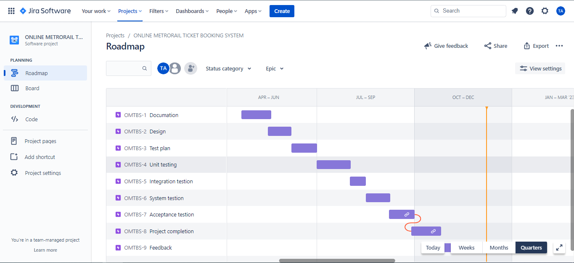

# 13. PLANNING RISKS AND CONTINGENCIES

The success of a software development project can be harmed by a number of risks. As a result, we must be prepared in every manner to ensure that the project is not affected by any risks. Due to schedule associated risk, time related risk is formed. If the schedule is not completed correctly, there may be issues with project timing, and the project may take longer to prepare. The project will not be completed on time, and the end-user will be dissatisfied. Costing-related risk can be caused by incorrect cost estimation. The majority of the costing risk stems from a scheduling issue. The longer it takes to prepare a project, the higher the cost will be. When a project's quality falls short of stakeholder expectations, there's a good chance it won't succeed. Technical debt can be caused by low-quality code. Other developers may find it difficult to examine or alter the code since it is tough to read. It could have been hurried and delivered without proper testing, resulting in a large number of bugs that could have been avoided. Because you rely heavily on their comments, it's critical to have an open, quick, and informative conversation with your stakeholders. If a client or stakeholder with whom you are working does not engage as much as they should with you or your team, your workflow and efficiency will suffer significantly.

# 14. APPROVALS

|  |  |
| --- | --- |
| **Project Manager** | Ashfat Al Rashid |
| **Developer** | Tahsin Ahmed |
| **Test Planner** | Ashfat Al Rashid |
| **Test Lead** | Rahman, Md Shohan Ur |
| **Tester** | Tajkia Faruk  Rahman, Md Shohan Ur |
| **End User** | Tahsin Ahmed  Tajkia Faruk |